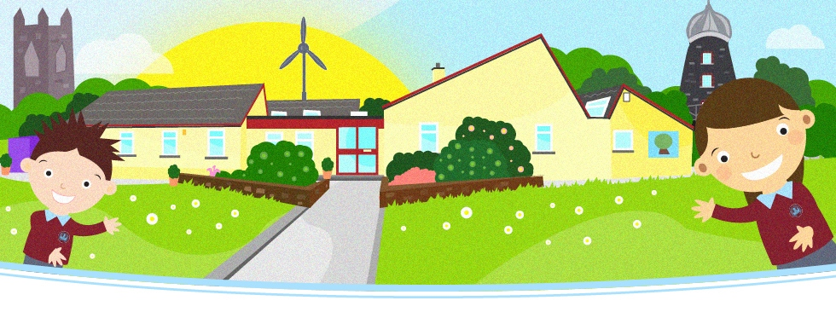

☺ Primary One ☺

**Letter From Your Child’s Teacher**

Welcome to the 2014 – 2015 school year in Knockloughrim Primary School! This is such an exciting time for your child. The first day of school is one of the most important milestones in your child’s life! I am looking forward to working with you and getting to know your child and helping them succeed in their education.

Please feel free to share any likes/dislikes or information you feel may benefit your child. If at any stage you have any questions or concerns feel free to drop me a note or contact me either before or after school.

**School Times**

[](http://www.hittoon.com/450/1062219-clipart-professor-owl-ringing-a-bell-1-royalty-free-vector-illustration.jpg)The arrangements for P1s school day:

School starts: 8.55am

Break: 10.45 – 11am

Lunch: 12.30 – 1.15pm

Home time: 2pm from 18th September (please try not to be late as this can cause distress)

**PE**

We will have PE on Monday, Wednesday and Friday. P1 will change into their full PE uniform from the beginning of the first term. PLEASE CLEARLY LABEL ALL UNIFORM (including shoes) otherwise uniform is easily lost. We encourage children to practise getting dressed at home to help them get changed quickly in school!

**Homework in P1**

Homework is set on a weekly basis and is usually handed out on Monday and is due to be returned at the end of that week. During the year the amount of homework will increase until they reach the following.

* MCj04300490000[1]Sounds
* Handwriting
* Reading
* Maths/Literacy activities
* Other activities including World Around Us activities, competitions, etc.

It is very important that you do not complete your child’s homework for them. If it is proving too difficult put a little note on the homework activity to let me know. It is really important that your child brings their homework folder to school every day as reading books cannot be exchanged, notes can be missed, etc if we do not have these.

**Themes:**

In P1 we focus on a topic each half term. Our first topic this year is ‘It’s Good To Be Me!’ and we will be focusing on this in our play, Would Around Us, PDMU, etc. We would be very grateful if you could send in an old pair of wellies (labelled) in a bag with your child that we can keep on their peg in school so we can enjoy outdoor play. They should also bring a waterproof coat to school every day.

**General Information**

We understand that young children love to bring their toys into school to show to their friends. Please do not allow your child to bring in precious or expensive toys as these are sent at your own risk. If you do allow your child to bring toys to school these should remain in their school bag during class time.

Any letters or reply slips, which need to be returned, can be put in your child’s homework folder. The children are encouraged to check them each morning and give things in. Dinner money needs to be labelled clearly inside an envelope and given to me on Monday if possible.

Your child can bring their own water bottle to keep in class which they can access throughout the day. Please make sure your child’s name is written clearly on their water bottle.

We encourage all of our children to be independent in looking after their belongings.

There is lots of important information on our school website and I will be posting photos and information throughout the course of the year so keep a wee eye on this!

Please let me know as soon as you can if your child has any wee worries or you’re just unsure of something.

Thank you and I look forward to a fantastic year!

Yours sincerely



H. Clarke

P1 teacher