
19th
Sept.
2014


KNOCKLOUGHRIM
SCHOOL NEWS


Welcome to our newsletter this week. We have had a really busy week in school as our routines continue to settle in. P1 are now staying their full day and after school clubs also commenced. We had our photographer in school on Tuesday and soccer training for our school team started back today. Please keep all our events and little learners in your thoughts this week. It takes a lot of effort to make a learning community like ours function and benefit so many so well and I pay tribute once again to all the adults who help this to be the case in Knockloughrim.
Cbooks Catalogue: Today several notes are going home with children including a catalogue for Cbooks. This catalogue only comes out once a school year. Year 3 children are encouraged to take up the offer inside the catalogue even if they don’t intend to purchase from the catalogue.
Pupil Christmas Card Designs: Today we received most of our Christmas card designs but not all monies. Could I please ask for outstanding designs and monies to be returned to school on Monday morning.
Accelerated Reading in P6/7: Here are a few snaps taken this week of P6/7 accelerating their reading through the AR programme in school this week. There are lots more on the class page of our website.

Curran Duck Race: A book of tickets is going home today to each family for our annual Curran Duck Race. This is an important annual fundraiser for our PTA and a really child centred and fun event for all the family. Please do your best to sell as many little ducks as possible as none of them want to be left behind in the bath while the rest get to swim down the River Moyola. Additional tickets can be acquired from our school office where unsold tickets and monies should be returned. Please note the change of date to Thursday 2nd October, weather permitting.
Names on Belongings: As mentioned in most of our newsletters already this year we would REALLY appreciate it if parents would make sure that children have their names on all pieces of their uniform, school and lunch bags. Each child will get a house point on Tuesday if they have their name on random uniform and belonging items checked by their teacher.

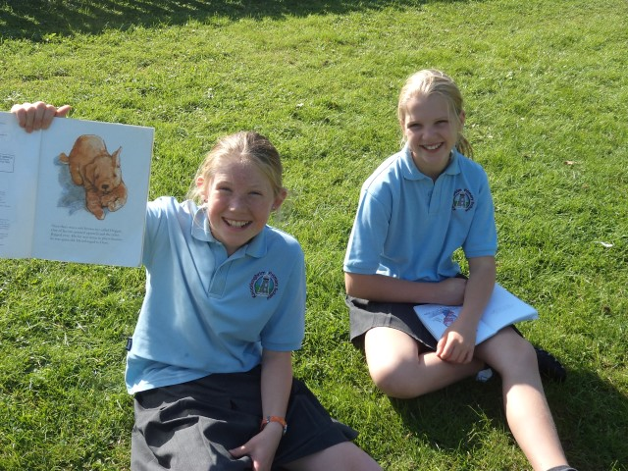
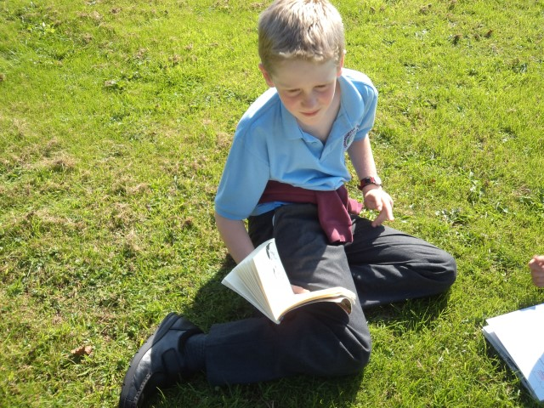


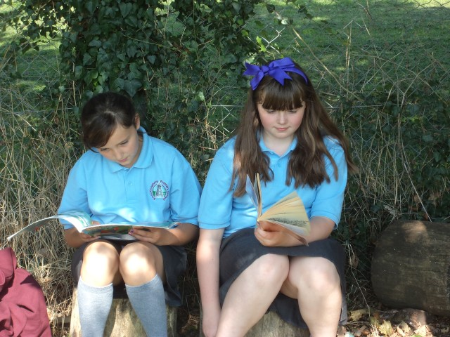
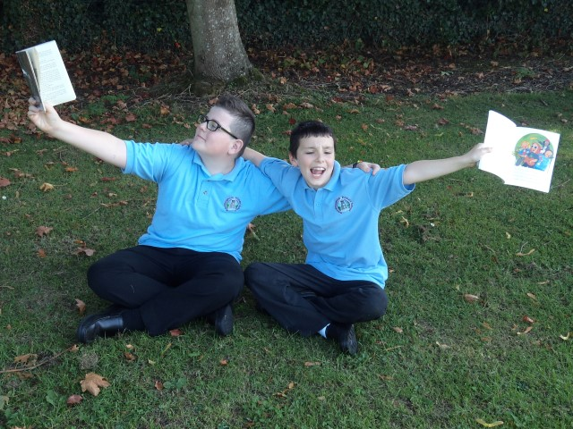
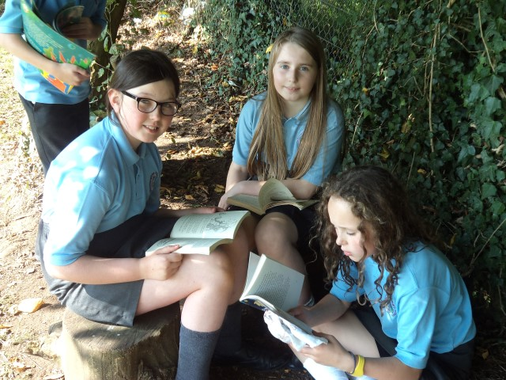

Windmill Club Extended Child Care For Week Commencing: Monday 22nd Sept. – (Costs: Up to 1hr = £2.50 or Longer than 1 hr up to 6pm = £8)
Names of Child/ren: | 1. | 2. | 3. | 4. | 5.
Days Required: | Monday ◻ | Tuesday ◻ | Wednesday ◻ | Thursday ◻ | Friday ◻
Pick Up Time: | __________pm. | __________pm. | __________pm. | __________pm. | __________pm.
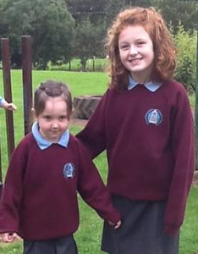
Week 1 of New Dinner Menu

